 | Autumn 1 | Autumn 2 | Spring 1 | Spring 2 | Summer 1 | Summer 2
Books | 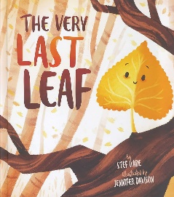  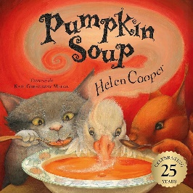  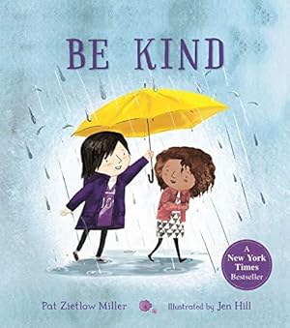 | 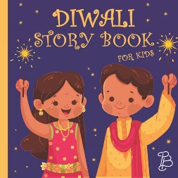  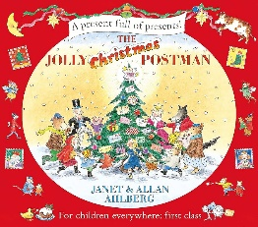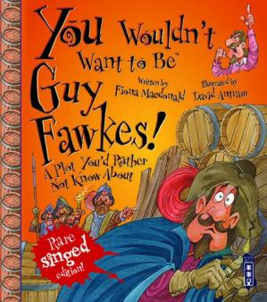 |   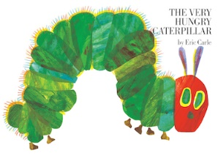 | 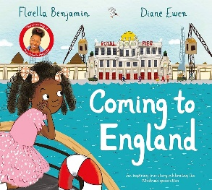  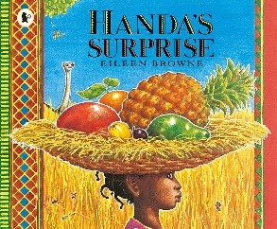 | 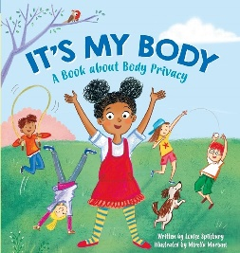  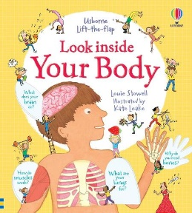  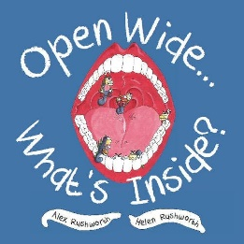 | 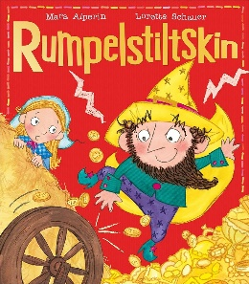  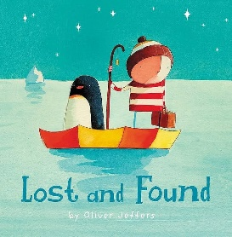  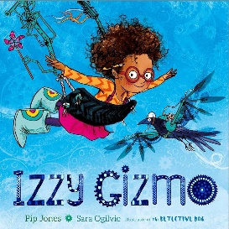
Literacy | Spelling - Letter Word Singular Plural | Sentence - Coordinating conjunctions: and | Punctuation - Capital letter  Full stop | Punctuation - Question mark Exclamation mark | Word types –  Adjectives  Verb  Noun | Poetry –  Alliteration
Reading | All pupils will complete RWI assessments at the start of the academic year and will be working to their individual reading targets based on the outcome of their initial assessments.
Maths | Number and place value  Addition and subtraction  Multiplication and division |  | Fraction  Measurements  Shape |  | Revision and consolidation  Statistics
Science | Plants | Lights | Animals including humans | Everyday materials | Animals including humans | Plants
Role Play | People who help us | Post office | Invention Station | Explorers | Doctors office | Shop
RSHE | T.E.A.M – school core values | Respecting ourselves and others | Diet and exercise | Making healthy relationships | Growing up | Money matters
Exploring the wider world | Changes of season | Celebrations including Diwali, Remembrance Day, Guy Fawkes and Christmas | Mary Seacole  International Women’s Day | Key features of different countries and how they compare to England - maps | Visiting the dentist/doctor. | Preparing to transition for the end of year.

