 | Autumn 1 | Autumn 2 | Spring 1 | Spring 2 | Summer 1 | Summer 2
Books | 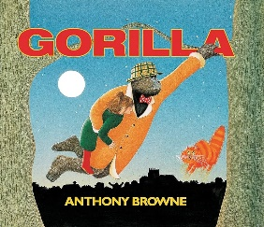  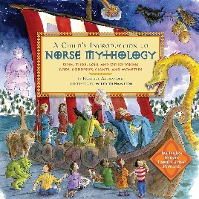 | 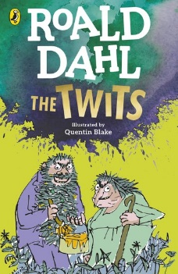 | 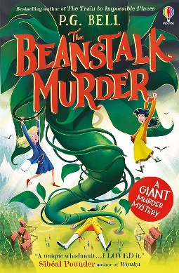  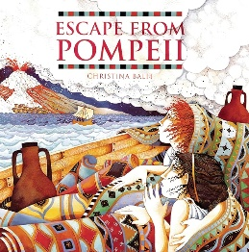 | 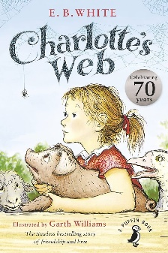  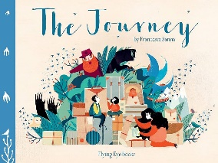 | 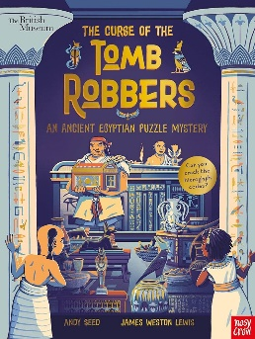 | 
Literacy | Suffixes  Prefixes  Conjunctions: when, before, after, while, so, because  Noun  Expanded noun phrases (with adjectives)  Adjectives  Verb  Adverbs  Prepositions  Capital letter  Full stop  Question mark Exclamation mark  Commas in a list Apostrophes (missing letters and singular |  | Consonant  vowels  Clauses  Present simple  Past simple  Inverted commas (or ‘speech marks’) and other speech punctuation e.g. commas  Apostrophes for plural possession |  | Plurals possessive  Subordinate clauses  Present progressive  Past progressive  Noun  Fronted adverbials Pronouns (including possessive) Determiners
Reading | All pupils will complete RWI assessments at the start of the academic year. Reading interventions will be put in place who still require phonic support. Those pupils who are able to move on will be following individual reading intervention plans.
Maths | Number and place value  Addition and subtraction  Multiplication and division |  | Fraction  Measurements  Shape |  | Revision and consolidation  Statistics
Science | Plants | Electricity | Light | Rocks | Animals including humans | Forces and magnets
RSHE | Online safety  E safety  Social media | Reflecting  Falling out and making up | Money sense | Stereotypes | Drugs and alcohol | Puberty and body issues
Exploring the wider world | Vikings | UK and it’s surrounding counties | Roman Britain | The UK vs the Caribbean | Ancient Egypt | Our local area

