Ormiston Academies Trust

# Health and Safety Statement of Intent

Policy version control

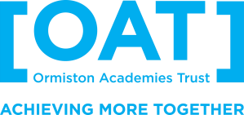

|  |  |
| --- | --- |
| Policy type | Statutory policy, Mandatory OAT template |
| Author | Louisa Sharpless, Head of Safety and Estates Compliance, and  James Miller, National Director of Infrastructure and Sustainability |
| Approved by | National Leadership Group, November 2024  F&C Committee, November 2024 |
| Approved by Trust Board | December 2024 |
| Release date | December 2024 |
| Review | December 2025 |
| Description of changes | ▪ Minor changes to remove specific number of schools |

# Contents

1. Statement of Intent .......................................................................................................... 3
2. Health & Safety Policy ....................................................................................................... 4

1. Statement of Intent

Ormiston Academies Trust (OAT) is a multi-academy trust responsible for a network of schools across the country. We are committed to ensuring the health, safety and wellbeing of our staff, students, contractors, visitors, and others who may be directly affected by our activities. We strive to be the benchmark of health and safety good practice across all sectors in which OAT operates.

In accordance with OAT Governance: Schemes of Delegation, the Trustees will be accountable for:

* The health and safety of all students, staff, contractors, visitors, and any person using the facilities
* Instituting a health and safety policy and updating in line with current legislation
* Checking that health and safety legislation and regulations are followed
* Ensuring that OAT have adequate insurance in place

Ensuring the safety of our community is of paramount importance, and this policy reflects our dedication to creating a safe learning environment.

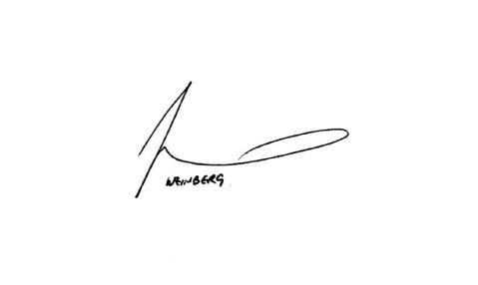

**Signed Chair of Trustees**

2. Health & Safety Policy

Ormiston Academies Trust are committed to:

* The provision of a productive and safe learning environment
* Preventing accidents and any work-related illnesses
* Managing health and safety risks in our academies and workplaces
* Providing clear instructions, information, and adequate training so that all staff are competent to carry out their work safely
* Joint consultation with employees on health and safety matters
* Safe arrangements for the handling, storage and transportation of any articles and substances
* Maintenance of safe systems of work and safe plant and equipment
* Maintaining safe and healthy working conditions and ensuring adequate welfare facilities are available
* Implementing emergency procedures, including evacuation in case of fire / other incident ▪ Monitoring and reviewing our policies regularly

We will:

* Comply with all statutory requirements as indicated within the Health and Safety at Work Act (1974)
* Determine, annually, those policies which will be mandatory for all OAT academies and making copies available, with a schedule for their review and update
* Minimise risks via assessment, policy and process
* Set high targets and objectives to develop a culture of continuous improvement
* Have adequate resources available to address health and safety issues, so far as is reasonably practicable
* Provide protective equipment and clothing as required
* Provide effective health and safety management systems embedded throughout our organisation
* Set and monitor the management of health and safety performance against clear goals and objectives
* Provide suitable resources to ensure effective health, safety, and risk management
* Identify and assess hazards and risks and allocate adequate resources to implement effective control measures
* Provide competent health and safety advice for all employees and associates ▪ Provide clear and regular communication around our health and safety performance

Signed Directors:

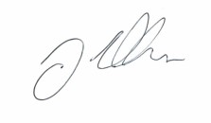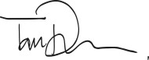

**CEO:** Tom Rees **National Director of Infrastructure and Sustainability:** James Miller